EXPERIMENT-7
Objective: To implement transfer learning using a pretrained ResNet18 model for accurate classification of chest X-ray images into Normal and Pneumonia classes, and to deploy the model for real-time predictions.
Description of the Model:
In this experiment, a Convolutional Neural Network (CNN) based on a pretrained ResNet18 architecture is implemented using the PyTorch library to classify chest X-ray images into Normal and Pneumonia categories.
Unlike traditional neural networks, CNNs are highly effective for image data because they can automatically learn spatial features such as edges, textures, and patterns. The ResNet18 model is pretrained on the ImageNet dataset, allowing it to leverage previously learned visual features and apply them to the medical imaging domain using transfer learning.
🏗️ Network Architecture
Input Image → Convolutional Layers → Residual Blocks → Fully Connected Layer → Output
- Input size = 224 × 224 × 3
- Pretrained model = ResNet18
- Final layer modified for binary classification
- Output size = 2 (Normal, Pneumonia)
The convolutional layers extract hierarchical features from the X-ray images, while the residual blocks help in training deeper networks efficiently by using shortcut connections.
🔄 Working of ResNet (Residual Learning)
In ResNet, instead of learning a direct mapping, the network learns a residual function:
$$H(x)=F(x)+x$$
Where:
- $x$= input
- $F(x)$= residual mapping
- $H(x)$= output
This helps in solving the vanishing gradient problem and allows deeper networks to train effectively.
⚙️ Transfer Learning Strategy
The model is trained in two phases:
🔵 Phase 1: Feature Extraction
- All pretrained layers are frozen
- Only the final fully connected layer is trained
🟢 Phase 2: Fine-Tuning
- Deeper layers (layer4) are unfrozen
- Model learns domain-specific medical features
This approach improves performance while reducing training time.
📉 Loss Function
$$Loss=-∑ylog⁡(\hat{y})$$
Cross-Entropy Loss is used to measure the difference between predicted probabilities and actual labels.
🔧 Training Mechanism
The model is trained using Backpropagation, where:
$$W=W-η⋅∇W$$
- Optimizer: Adam
- Learning Rate: 0.001 (Phase 1), 0.0001 (Phase 2)
The optimizer updates the weights to minimize the loss and improve prediction accuracy.
CODE:
import torch
import torch.nn as nn
import torch.optim as optim
import time
from tqdm import tqdm

from torchvision import datasets, transforms
from torchvision.models import resnet18, ResNet18_Weights
import matplotlib.pyplot as plt

from sklearn.model_selection import train_test_split
from torch.utils.data import Dataset, DataLoader
from PIL import Image

torch.backends.cudnn.benchmark = True

device = torch.device("cuda" if torch.cuda.is_available() else "cpu")
print("✅ Using device:", device)

train_transform = transforms.Compose([
transforms.Resize((224, 224)),
transforms.RandomHorizontalFlip(),
transforms.RandomRotation(10),
transforms.ToTensor(),
transforms.Normalize([0.485, 0.456, 0.406],
[0.229, 0.224, 0.225])
])

val_transform = transforms.Compose([
transforms.Resize((224, 224)),
transforms.ToTensor(),
transforms.Normalize([0.485, 0.456, 0.406],
[0.229, 0.224, 0.225])
])

print("✅ Transformations defined")

data_dir = "../data/chest_xray/train"

full_dataset = datasets.ImageFolder(data_dir)

file_paths = [x[0] for x in full_dataset.samples]
labels = [x[1] for x in full_dataset.samples]

train_paths, temp_paths, train_labels, temp_labels = train_test_split(
file_paths, labels, test_size=0.3, stratify=labels, random_state=42
)

val_paths, test_paths, val_labels, test_labels = train_test_split(
temp_paths, temp_labels, test_size=0.5, stratify=temp_labels, random_state=42
)

print(f"✅ Train: {len(train_paths)} | Val: {len(val_paths)} | Test: {len(test_paths)}")

class CustomDataset(Dataset):
def __init__(self, file_paths, labels, transform=None):
self.file_paths = file_paths
self.labels = labels
self.transform = transform

def __len__(self):
return len(self.file_paths)

def __getitem__(self, idx):
image = Image.open(self.file_paths[idx]).convert("RGB")
label = self.labels[idx]

if self.transform:
image = self.transform(image)

return image, label

print("✅ Custom dataset ready")

train_dataset = CustomDataset(train_paths, train_labels, train_transform)
val_dataset = CustomDataset(val_paths, val_labels, val_transform)
test_dataset = CustomDataset(test_paths, test_labels, val_transform)

train_loader = DataLoader(train_dataset, batch_size=32, shuffle=True, num_workers=0, pin_memory=True)
val_loader = DataLoader(val_dataset, batch_size=32, num_workers=0, pin_memory=True)
test_loader = DataLoader(test_dataset, batch_size=32, num_workers=0, pin_memory=True)

print("✅ DataLoaders created")

model = resnet18(weights=ResNet18_Weights.DEFAULT)

num_features = model.fc.in_features

model.fc = nn.Sequential( # type: ignore
nn.Linear(num_features, 256),
nn.ReLU(),
nn.Dropout(0.5),
nn.Linear(256, 2)
)

model = model.to(device)

print("✅ Model ready")

criterion = nn.CrossEntropyLoss()
print("✅ Loss function defined")

import os

os.makedirs("../models", exist_ok=True)
os.makedirs("../outputs/graphs", exist_ok=True)

print("✅ Folders ready")

def train_model(model, optimizer, epochs):

train_losses, val_losses = [], []
train_accs, val_accs = [], []
best_val_acc = 0

for epoch in range(epochs):
start_time = time.time()

print(f"\n🔥 Epoch [{epoch+1}/{epochs}]")

model.train()
train_loss, correct, total = 0, 0, 0
loop = tqdm(train_loader, leave=False)

for images, labels in loop:
images = images.to(device)
labels = labels.to(device)

outputs = model(images)
loss = criterion(outputs, labels)

optimizer.zero_grad()
loss.backward()
optimizer.step()

train_loss += loss.item()

_, predicted = torch.max(outputs, 1)
total += labels.size(0)
correct += (predicted == labels).sum().item()

# 🔥 Live batch update
loop.set_postfix(
loss=f"{loss.item():.4f}",
acc=f"{100 * correct / total:.2f}%"
)

train_loss /= len(train_loader)
train_acc = 100 * correct / total

model.eval()
val_loss, correct, total = 0, 0, 0

with torch.no_grad():
for images, labels in val_loader:
images = images.to(device)
labels = labels.to(device)

outputs = model(images)
loss = criterion(outputs, labels)

val_loss += loss.item()

_, predicted = torch.max(outputs, 1)
total += labels.size(0)
correct += (predicted == labels).sum().item()

val_loss /= len(val_loader)
val_acc = 100 * correct / total

# 🔥 SAVE BEST MODEL
if val_acc > best_val_acc:
best_val_acc = val_acc
torch.save(model.state_dict(), "../models/best_model.pth")
print("✅ Best model saved!")

end_time = time.time()

# 🔥 KERAS-STYLE OUTPUT
print(f"\nEpoch {epoch+1}/{epochs}")
print(f"{len(train_loader)}/{len(train_loader)} "
f"- {end_time - start_time:.0f}s "
f"- loss: {train_loss:.4f} "
f"- accuracy: {train_acc:.2f}% "
f"- val_loss: {val_loss:.4f} "
f"- val_accuracy: {val_acc:.2f}%")

train_losses.append(train_loss)
val_losses.append(val_loss)
train_accs.append(train_acc)
val_accs.append(val_acc)

return train_losses, val_losses, train_accs, val_accs

print("🔵 Phase 1: Feature Extraction")

for param in model.parameters():
param.requires_grad = False

for param in model.fc.parameters():
param.requires_grad = True

optimizer = optim.Adam(model.fc.parameters(), lr=0.001)

train_losses, val_losses, train_accs, val_accs = train_model(model, optimizer, epochs=5)

print("🟢 Phase 2: Fine-Tuning")

for param in model.parameters():
param.requires_grad = False

for param in model.layer4.parameters():
param.requires_grad = True

for param in model.fc.parameters():
param.requires_grad = True

optimizer = optim.Adam(model.parameters(), lr=0.0001)

ft_train_losses, ft_val_losses, ft_train_accs, ft_val_accs = train_model(model, optimizer, epochs=5)

import os
import seaborn as sns
from sklearn.metrics import confusion_matrix, classification_report

os.makedirs("../outputs/graphs", exist_ok=True)

all_train_accs = train_accs + ft_train_accs
all_val_accs = val_accs + ft_val_accs

all_train_losses = train_losses + ft_train_losses
all_val_losses = val_losses + ft_val_losses

plt.figure(figsize=(14,5))

plt.subplot(1,2,1)
plt.plot(all_train_accs, label="Train Accuracy")
plt.plot(all_val_accs, label="Validation Accuracy")
plt.title("Accuracy vs Epoch")
plt.xlabel("Epoch")
plt.ylabel("Accuracy (%)")
plt.legend()
plt.grid()

plt.subplot(1,2,2)
plt.plot(all_train_losses, label="Train Loss")
plt.plot(all_val_losses, label="Validation Loss")
plt.title("Loss vs Epoch")
plt.xlabel("Epoch")
plt.ylabel("Loss")
plt.legend()
plt.grid()

plt.tight_layout()
plt.savefig("../outputs/graphs/training_analysis.png")
plt.show()

all_preds = []
all_labels = []

model.eval()
with torch.no_grad():
for images, labels in test_loader:
images = images.to(device)
outputs = model(images)
_, preds = torch.max(outputs, 1)

all_preds.extend(preds.cpu().numpy())
all_labels.extend(labels.numpy())

cm = confusion_matrix(all_labels, all_preds)

plt.figure(figsize=(6,5))
sns.heatmap(cm, annot=True, fmt="d", cmap="Blues")
plt.title("Confusion Matrix")
plt.xlabel("Predicted Label")
plt.ylabel("True Label")

plt.savefig("../outputs/graphs/confusion_matrix.png")
plt.show()

def unnormalize(img):
mean = torch.tensor([0.485, 0.456, 0.406]).view(3,1,1)
std = torch.tensor([0.229, 0.224, 0.225]).view(3,1,1)
return img * std + mean

images, labels = next(iter(test_loader))

images = images.to(device)
outputs = model(images)
_, preds = torch.max(outputs, 1)

images = images.cpu()

plt.figure(figsize=(12,6))

for i in range(8):
plt.subplot(2,4,i+1)

img = unnormalize(images[i])
img = img.permute(1,2,0).numpy()

plt.imshow(img)
plt.title(f"P:{preds[i].item()} | A:{labels[i].item()}")
plt.axis("off")

plt.suptitle("Sample Predictions")

plt.savefig("../outputs/graphs/sample_predictions.png")
plt.show()

print("\nClassification Report:\n")
print(classification_report(all_labels, all_preds, target_names=["Normal", "Pneumonia"]))

model.load_state_dict(torch.load("../models/best_model.pth"))
model.eval()

print("✅ Best model loaded")

correct = 0
total = 0

with torch.no_grad():
for images, labels in test_loader:
images = images.to(device)
labels = labels.to(device)

outputs = model(images)
_, predicted = torch.max(outputs, 1)

total += labels.size(0)
correct += (predicted == labels).sum().item()
test_acc = 100 * correct / total
print(f"🔥 Test Accuracy: {test_acc:.2f}%")
torch.save(model.state_dict(), "../models/final_model.pth")
print("✅ Model saved successfully")
OUTPUT:
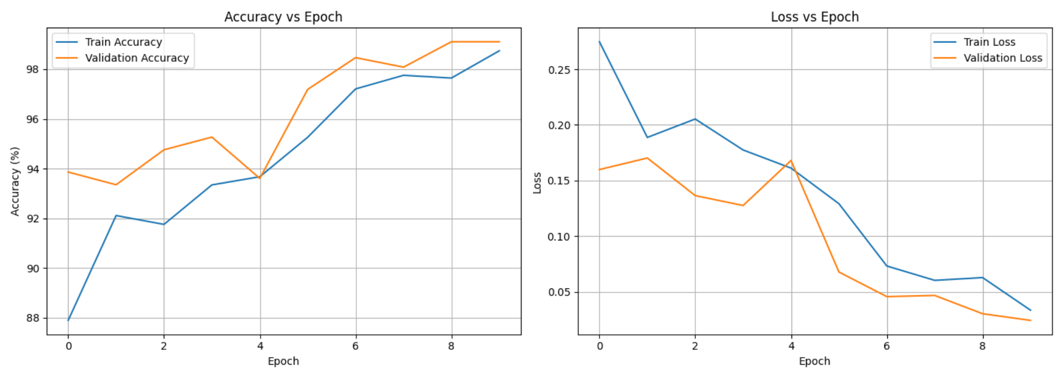
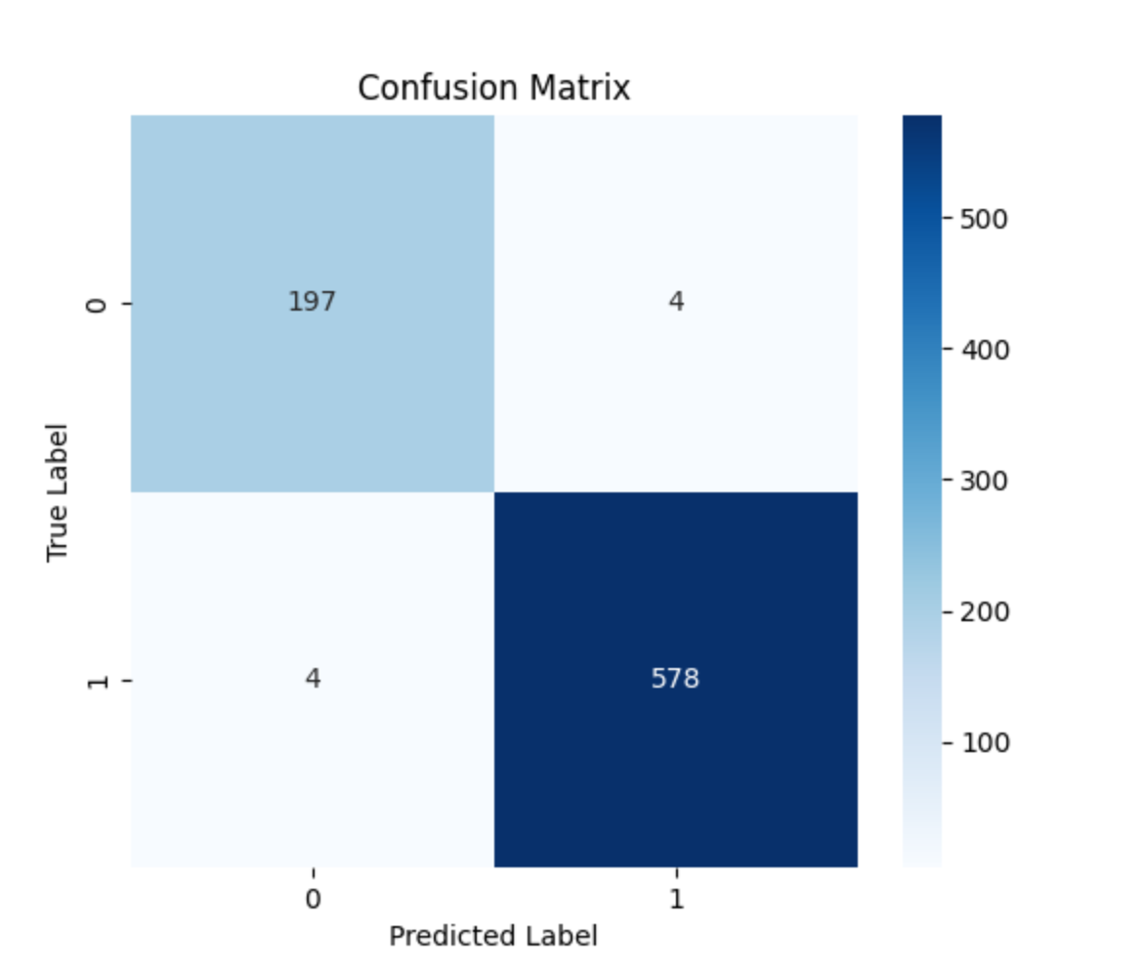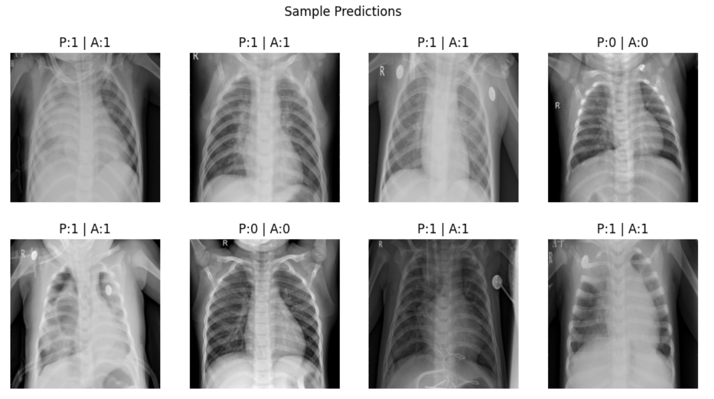
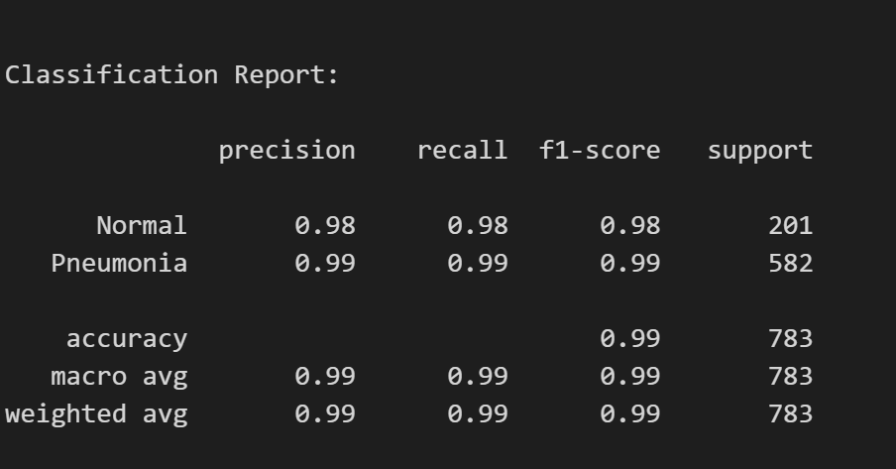
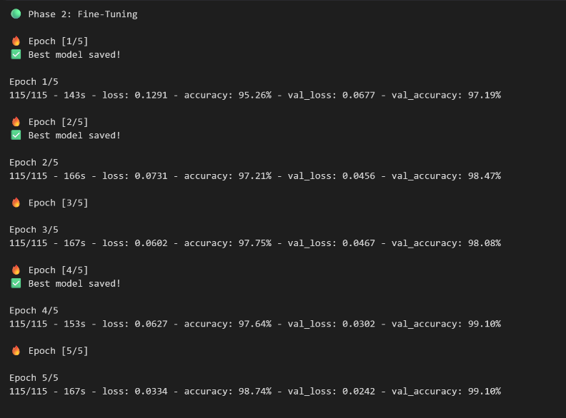
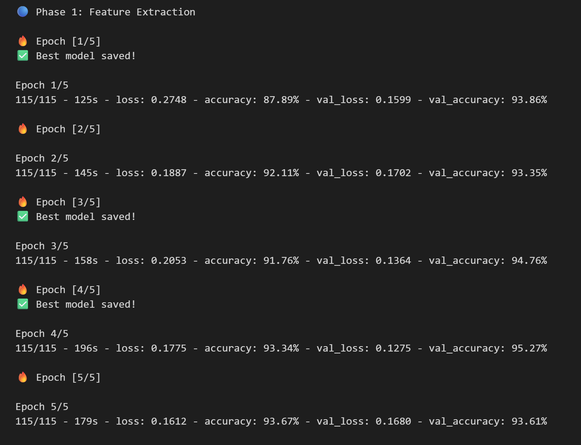
🧾 Description of the Code
The program begins by importing required libraries such as PyTorch for building and training the deep learning model, Torchvision for pretrained models and image transformations, NumPy for numerical operations, Matplotlib and Seaborn for visualization, and scikit-learn for data splitting and evaluation metrics.
The dataset is loaded using PyTorch’s ImageFolder class, which automatically assigns labels based on folder names (Normal and Pneumonia). Since the original validation set is very small, the dataset is manually split into three parts using train_test_split():
- 70% for training
- 15% for validation
- 15% for testing
This ensures proper evaluation and avoids unstable validation results.
To handle image data, preprocessing is applied using transforms. The images are resized to 224×224 pixels, converted into tensors, and normalized using ImageNet mean and standard deviation values. Additionally, data augmentation techniques such as random horizontal flipping and rotation are applied to improve model generalization and reduce overfitting.
A custom dataset class is implemented to load images dynamically from file paths and apply transformations. This dataset is then passed to PyTorch DataLoader, which enables efficient batch processing, shuffling, and faster training.
The model is created using a pretrained ResNet18 architecture from Torchvision. The final fully connected layer is modified to perform binary classification. A dropout layer is added to reduce overfitting and improve generalization.
The training process is implemented in a reusable function train_model(). This function performs:
- Forward pass (prediction generation)
- Loss calculation using CrossEntropyLoss
- Backpropagation to compute gradients
- Weight updates using the Adam optimizer
The model is trained in two phases:
🔵 Phase 1: Feature Extraction
- All pretrained layers are frozen
- Only the final layer is trained
🟢 Phase 2: Fine-Tuning
- Deeper layers (layer4) are unfrozen
- Model learns more specific medical features
During each epoch:
- Training loss and accuracy are calculated
- Validation loss and accuracy are evaluated
- The best model is saved based on highest validation accuracy
The program prints epoch-wise results in a structured format similar to deep learning frameworks, helping track performance over time.
After training, multiple visualizations are generated:
- Accuracy vs Epoch graph
- Loss vs Epoch graph
- Confusion Matrix to analyze predictions
- Sample Predictions to visually inspect model output
For final evaluation, the best saved model is loaded and tested on unseen test data. The test accuracy is calculated, which reflects real-world performance of the model.
Additionally, a Streamlit web application is created where users can upload chest X-ray images. The image is preprocessed, passed through the trained model, and the prediction (Normal or Pneumonia) along with confidence score is displayed in real time.
At the end, the trained model is saved for future use, ensuring that it can be reused without retraining.
📊 Performance Evaluation
(Pneumonia Detection using ResNet18 – Transfer Learning)
🟢 Training Results
During training, the model was trained in two phases (Feature Extraction + Fine-Tuning) using training and validation datasets.
Observations:
• Training accuracy increased from ~87% to ~98.7%
• Validation accuracy improved from ~93% to ~99.1%
• Training loss decreased significantly across epochs
• Validation loss also decreased and remained stable
👉 This indicates that the model is learning effectively and achieving high accuracy without severe overfitting, as both training and validation metrics show similar trends.
🧪 Prediction Behavior
The model was evaluated on unseen test data, and predictions were compared with actual labels.
Observations:
• Test accuracy achieved: 97.96%
• Predictions are highly accurate for both Normal and Pneumonia classes
• Model successfully identifies patterns in chest X-ray images
• Very few misclassifications observed
👉 This shows that the model is able to generalize well to new unseen medical data.
📈 Learning Behavior Analysis
• In initial epochs, accuracy is lower and loss is higher (model learning basic features)
• As training progresses, accuracy increases steadily
• Fine-tuning phase significantly boosts performance
• After a few epochs, validation accuracy stabilizes near maximum
👉 Smooth improvement indicates:
- Proper learning rate
- Effective transfer learning
- Stable training process
📉 Graph Interpretation
🔹 Accuracy vs Epoch Graph
• Shows a consistent increase in both training and validation accuracy
• Validation accuracy reaches very high values (~99%)
• Small gap between curves indicates good generalization
• No major fluctuations → stable learning
🔹 Loss vs Epoch Graph
• Training and validation loss decrease over time
• No sudden spikes → stable optimization
• Low final loss indicates strong model confidenc
🔹 Confusion Matrix
• Majority of predictions lie on the diagonal (correct predictions)
• Very few false positives and false negatives
• Indicates strong classification performance
🔹 Sample Predictions
• Model predictions match actual labels in most cases
• Visual inspection confirms correct classification
• Demonstrates practical usability of the model
📝 My Comments (Limitations & Improvements)
From this experiment, it is clear that transfer learning using a pretrained ResNet18 model can effectively classify medical images such as chest X-rays into Normal and Pneumonia categories with high accuracy. The model is able to extract meaningful visual features and generalize well on unseen data, as reflected by the high validation and test accuracy.
However, the performance of the model depends heavily on factors such as data quality, image preprocessing, learning rate, number of epochs, and the extent of fine-tuning. Improper selection of these parameters can lead to overfitting, underfitting, or unstable training behavior.
One limitation of this implementation is that it relies on a relatively small and domain-specific dataset, which may not fully represent real-world medical variations. Additionally, the model acts as a black-box, meaning it does not provide clear explanations for its predictions, which is a critical requirement in medical applications.
Another limitation is that only a ResNet18 architecture is used. While efficient, it may not capture highly complex patterns compared to deeper architectures. Also, the model is trained for binary classification only and does not distinguish between different types of pneumonia (e.g., viral vs bacterial).

